**# Analysis Car’s Data.**

**# Project Description:**

* + This Project Aims to analysis Car Data Using Big Data analysis tools.
  + Analysis old Car Data and Create Conclusion to help new Upcoming Car’s model in market.
  + Create Bot To help Find Data for Special Purpose.

**# Technologies Used:**

* + Python
  + Sql
  + Java
  + Apache Spark (Spark.sql).
  + Anaconda (jupyter Notebook).
  + Hadoop(winutil.ssh)

**#List of Features**

This Project analyses the old Car Data to get the

* Total Count of Sell Cars Brand Wise and find which is most seller also result show in chart?
* Which is most Popular model in first top of seller also result show in chart?
* Create bot for get input brand name from user and show all model in those Brand and show top seller model in chart Format.
* All Car brand’s top sell model compared to each other and show in chart?
* mostly used Fuel Type and compare and show in chart
* find which Engine Type is most Popular and compared fuel type wise Engine Type?
* Which is most Popular transmission?
* Find Year by Cars count also find?
* Create bot to get input (lower price bond, high price bond, fuel type) from user and show all cars in those price bond?

**#To-Do List:**

* More queries to be added.

#**Getting Started:**

1. **Set Platform.**

Download Spark 2.7.1 or above, Anaconda, Hadoop-Winutil.ssh, data set

1. **Install Platform Related Software. Set also Environment Variable.**
2. **Using Anaconda Prompt Install Following Packages.**

pyspark, matplotlib, pandas, pylab

**4.Create Spark Session in our case (“Car_data”).**

**5. Upload CSV file in Data Frame using (.load ).**

**6.Create Query Using Spark.sql(“ ”)**

**7.Convert Query Output into Bar Chart using matplotlib**

**8.Start executing Queries.**

**#Output**

* **My Car_Data Table Schema is Following:**

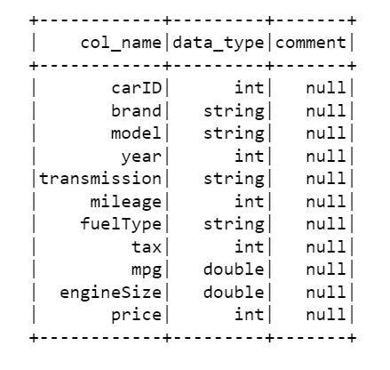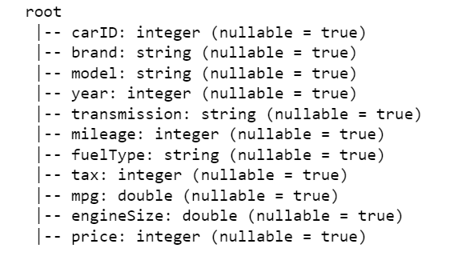

* 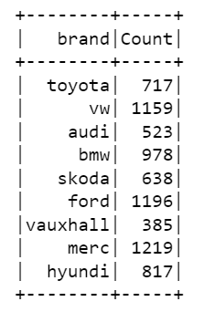**Q1. Most Popular Car Manufacture Brand is:**

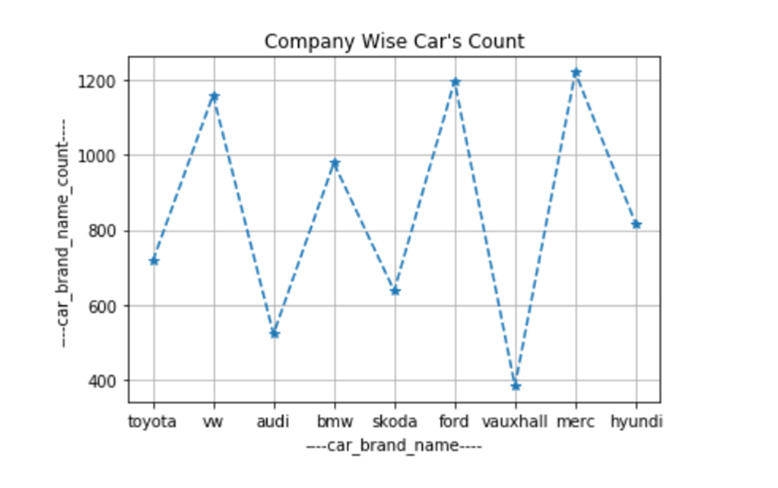

# Q2. Which is most Popular model in merc ?

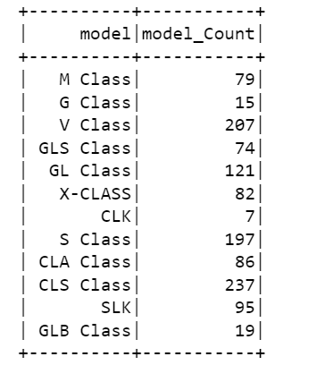

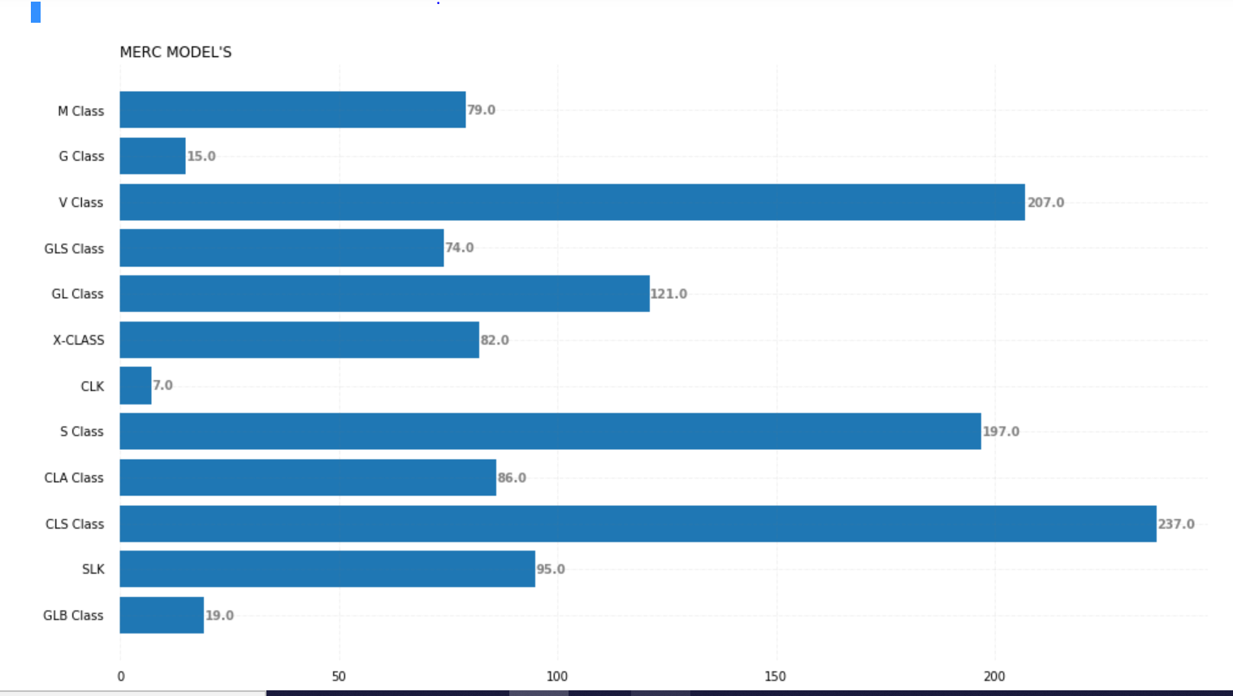

# q.4 Shown Every Brand Top Sell Model Cars ?

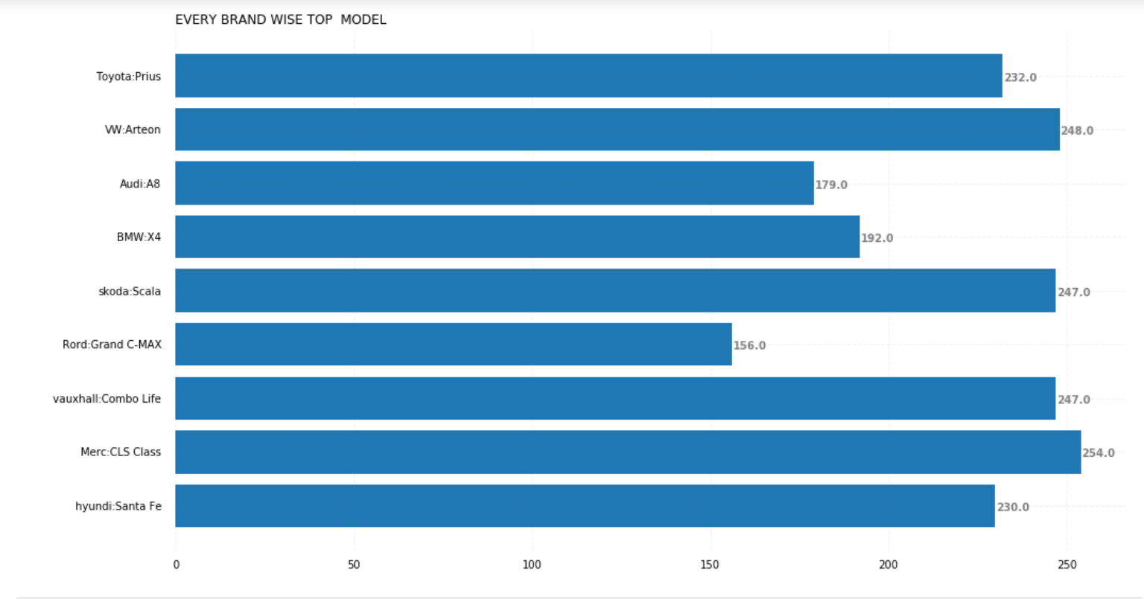

#Q5. Mostly used Fuel Type.

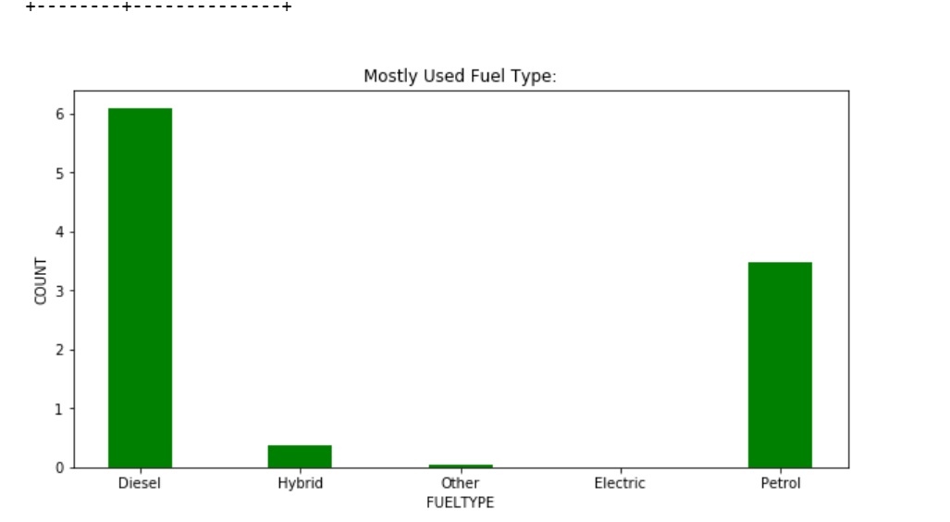

#Q6. find which Engine Type is popular and compare different Engine Type with fuel type wise?

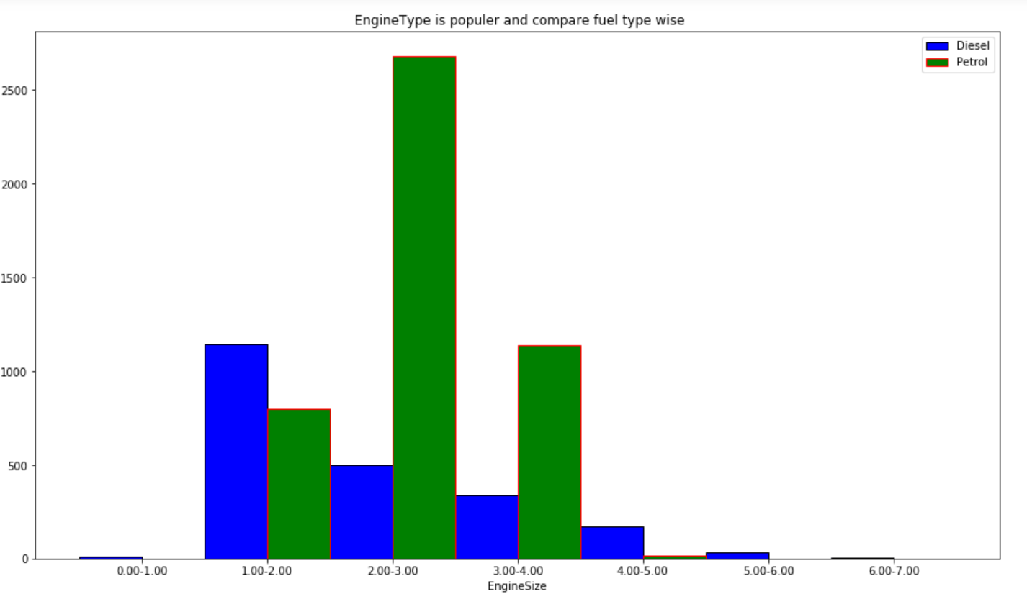

# Q7. Which is most Popular transmission?

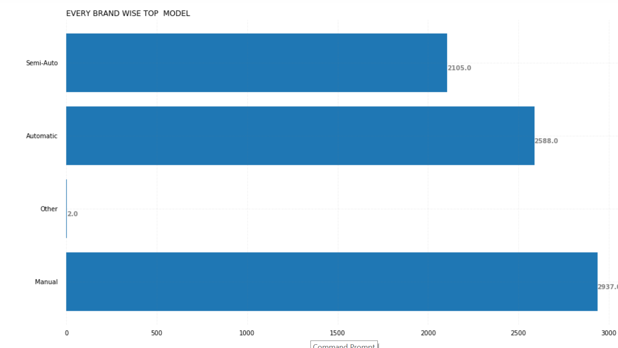

# Q7.Which is most Popular transmission

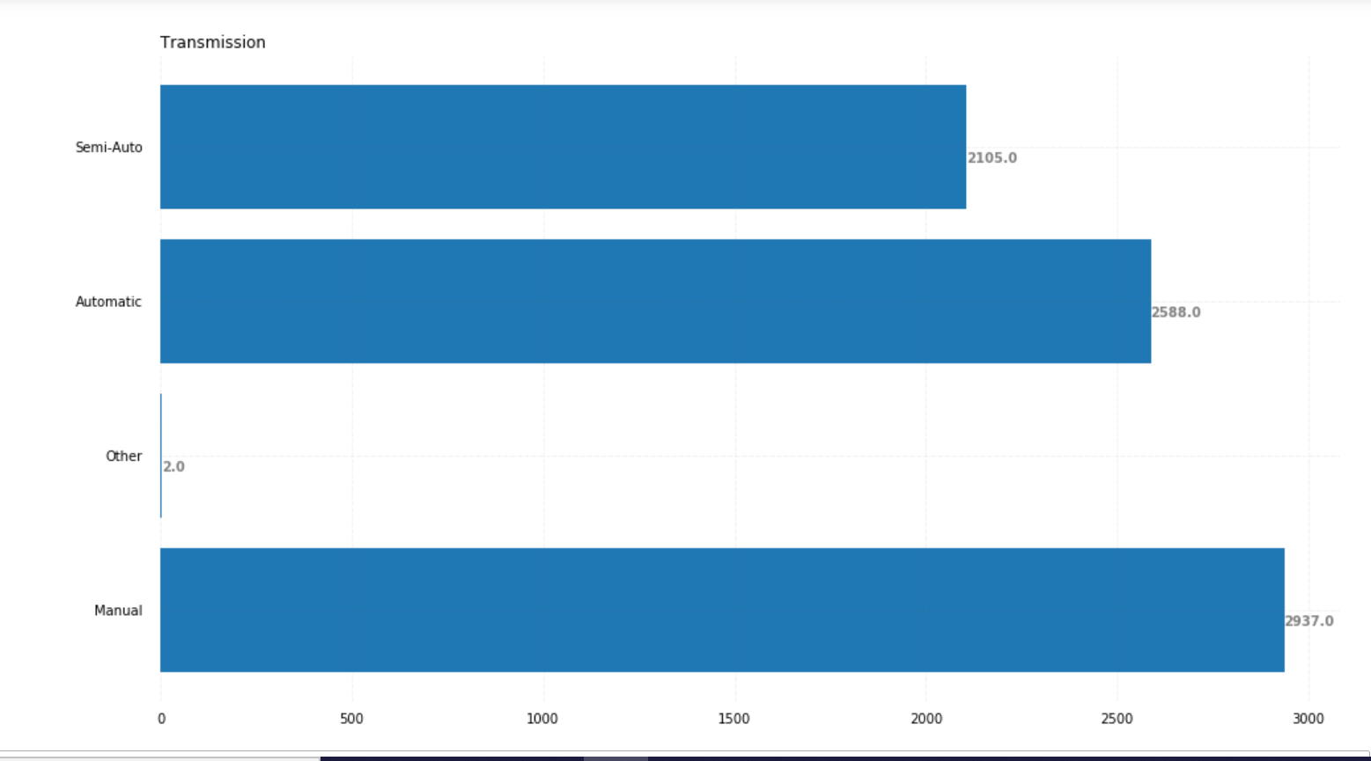

#Q8. find how many car's Manufacture in year's and compare petrol and Diesel wise count ?

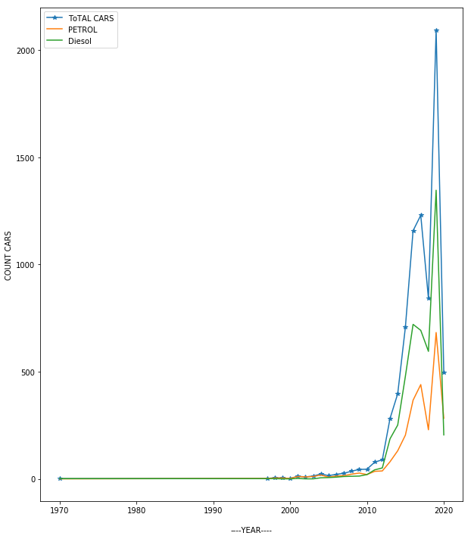

#Q9. Compare top Model AVG Brand wise?

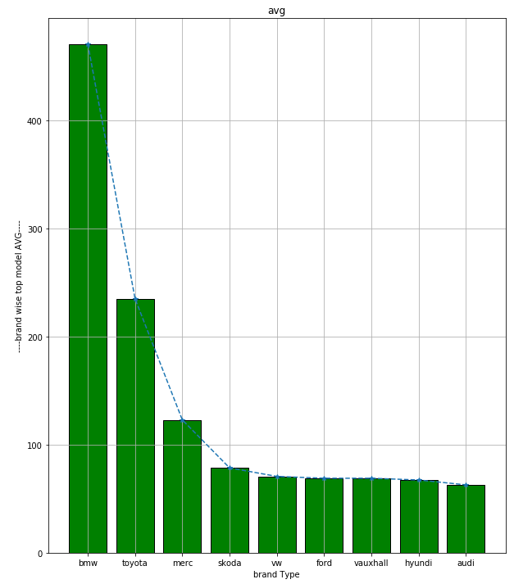

# Q10.Find MIN and max tax each model compares with brand ?

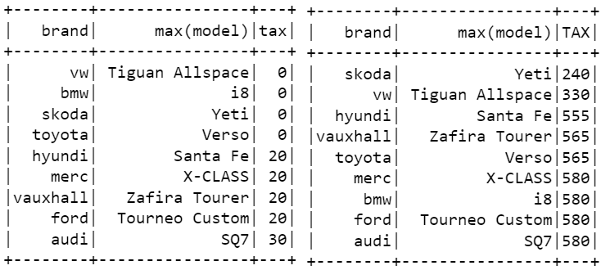

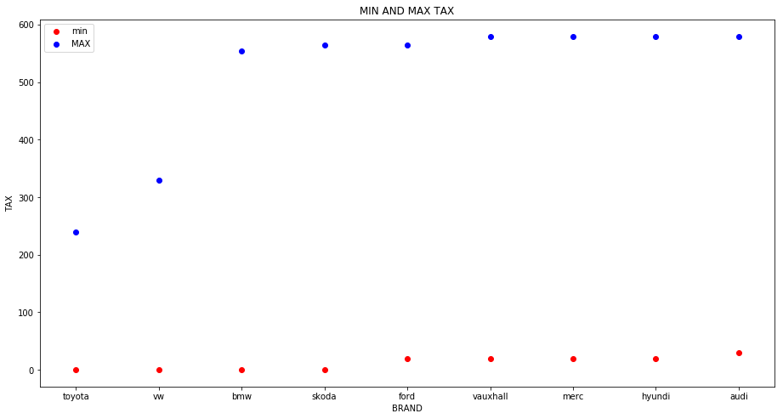

Q11. Create Bot For Help to find cars?

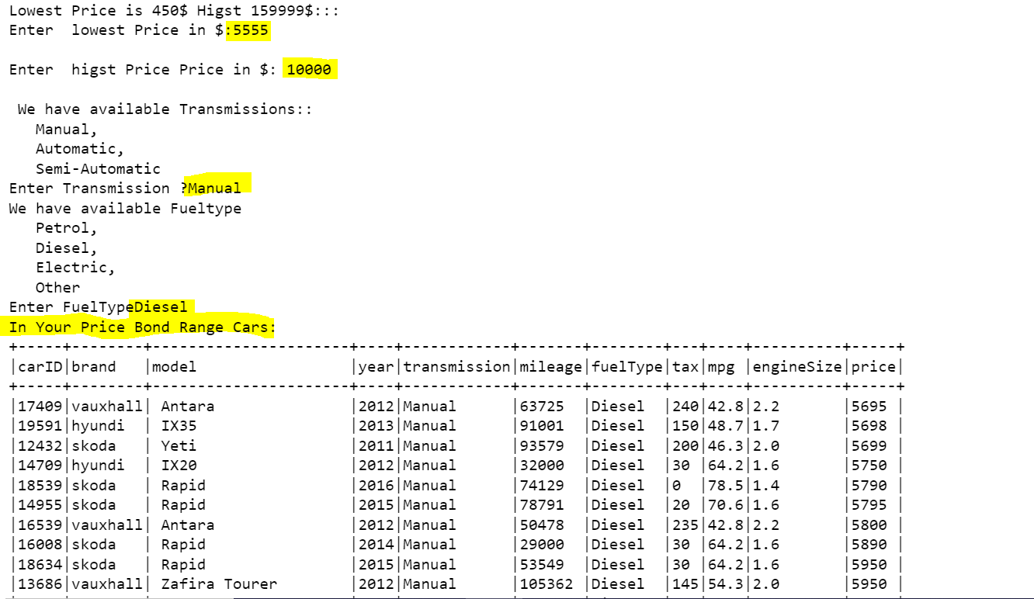

* END